## Question 1:

Logic gates implement Boolean functions, performing logical operations on one or more inputs and outputting a single binary value.

Which table correctly describes the Boolean function implemented by each gate?

## Question 2:

The diagram below shows a circuit with three gates, where the output from two AND gates are sent into a third AND gate. The circuit has four inputs (A, B, C, D), two for each AND gate.

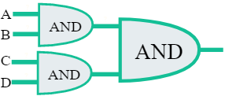

If the final output is 111, what are possible states of inputs A, B, C, and D?

## Question 3:

Digital alarm clocks display information and visual indicators to help people wake up on time:

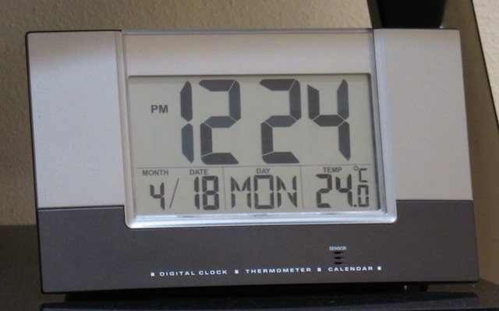

Which of the displays could be represented by a single bit?

## Question 4:

Which of these are examples of metadata for an audio file of a song recording?

1. The timestamp when the file was created
2. The volume at 13 seconds
3. The frequency of the note at 1:30
4. The title of the song
5. The number of bytes of data in the file
6. The artist of the song

## Question 5:

This paragraph describes how a computer works.

Fill in the blanks:

After a computer receives data from an **[input | output]**  device, like a keyboard or mouse, it goes to the **[hard drives | CPU | RAM | Memory]** for processing. The data is stored as **[Zip files | binary data | Hexadecimal numbers | GIFs]**. When it's done processing the data, the computer sends it to an **[Input | Output]** device, like a monitor or printer.

## Question 6:

Which of these best describe what a binary digit can store?

1. A binary digit can store one of the values from 0 - 9.
2. A binary digit can store one of two values, 0 or 1.
3. A binary digit can store a series of two 0/1 values, such as [1, 1].
4. A binary digit can store a series of two single-digit values, such as [4, 8].

## Question 7:

Abigail is using a computer that reports sizes in the standard units of bytes (B) and kilobytes (KB). Wilmer is using a computer that only reports in bytes. They're working on a project together, and they need a list of all their files sorted by size.

Which of these lists correctly sorts the files from largest size to smallest size?

1. 
2. 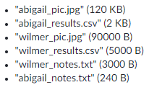
3. 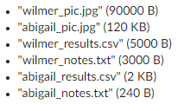
4. 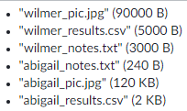
5. 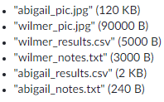

## Question 8:

The following circuit takes two inputs, sends each input through a NOT gate, and then sends those outputs through an OR gate. This circuit is logically equivalent to the NAND logic gate, a common gate in computers.

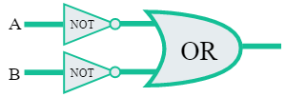

Fill out the truth table for the circuit by entering a 0 or 1 in the output column for each row:

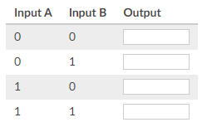

## Question 9:

A truth table shows the output values for a logic gate based on a set of input values.

Consider the following truth table:

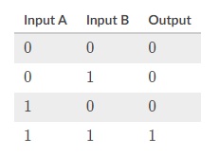

Which logic gate has a truth table that looks like that table?